
AQI Prediction & Forecasting System
Contributor:
Saqib Ahmad Siddiqui
Instructor:
Muhammad Mobeen
Project:
Next 3-Days Average Air Quality Index (AQI) Forecasting System for Multan, Pakistan
Program:
10Pearls Shine (Data Science Cohort)
Year:
February, 2026

1. Project Title

Next 3-Days Average Air Quality Index (AQI) Forecasting System - Multan, Pakistan
A machine learning-based system that predicts average air quality conditions for the next 3 days using real-time data collection, advanced feature engineering, and multiple classification models.

2. Context
Air pollution is a significant public health concern in Multan, Pakistan. Current air quality information is often limited to real-time measurements without predictive insights. Citizens and health authorities lack advance warning of deteriorating air quality conditions, making it difficult to take preventive measures.
This project addresses the need for accurate, 3-day ahead average AQI predictions to help citizens make informed decisions about outdoor activities and health precautions.

3. Project Information

3.1 Objective
To build a production-ready machine learning system that:
- Collects real-time air quality data hourly
- Feature Engineers intelligent features (40+ features)
- Trains 5 classification models daily
- Generates 72-hour recursive forecasts
- Provides predictions via interactive dashboard and FastAPI

3.2 Key Features

Data Pipeline:
- Hourly data collection from OpenWeatherAPI
- Real-time feature engineering (40+ features)
- Hopsworks Feature Store integration

Machine Learning:
- 5 Classification Models:
  - Random Forest Classifier
  - Histogram Gradient Boosting Classifier
  - LightGBM Classifier
  - Decision Tree Classifier
  - Sklearn Gradient Boosting Classifier
- Auto model selection by F1 score
- Class imbalance handling (stratified split + balanced weights)
- NaN value imputation (SimpleImputer)

User Interface:
- Streamlit interactive dashboard (dark theme)
- 3-day forecast with color-coded alerts
- Model performance comparison
- System information page

API:
- FastAPI endpoints
- Robust error handling and recovery

Automation:
- GitHub Actions CI/CD pipelines
- Hourly data collection
- Daily model training and prediction
- 100% serverless architecture

3.3 Technology Stack
Component | Technology
ML Framework | scikit-learn, LightGBM
Feature Store | Hopsworks 4.6.2
Data Processing | Pandas, NumPy
Dashboard | Streamlit
API | FastAPI
Data Source | OpenWeatherAPI
CI/CD | GitHub Actions
Deployment | Streamlit Cloud
Language | Python 3.11+

3.4 Model Performance
All models trained on 6,500+ records with AQI categories (1-5) and selected model based on best metrices.

4. Project Screenshots

4.1 Streamlit Dashboard - 3-Day Forecast
AQI Forecasting System
Next 3-days Air Quality Index Prediction for Multan
[3-Day Forecast Cards with AQI values and alerts]
[Interactive trend chart showing AQI trajectory]
[Color-coded categories: Good, Fair, Moderate, Poor, Very Poor]
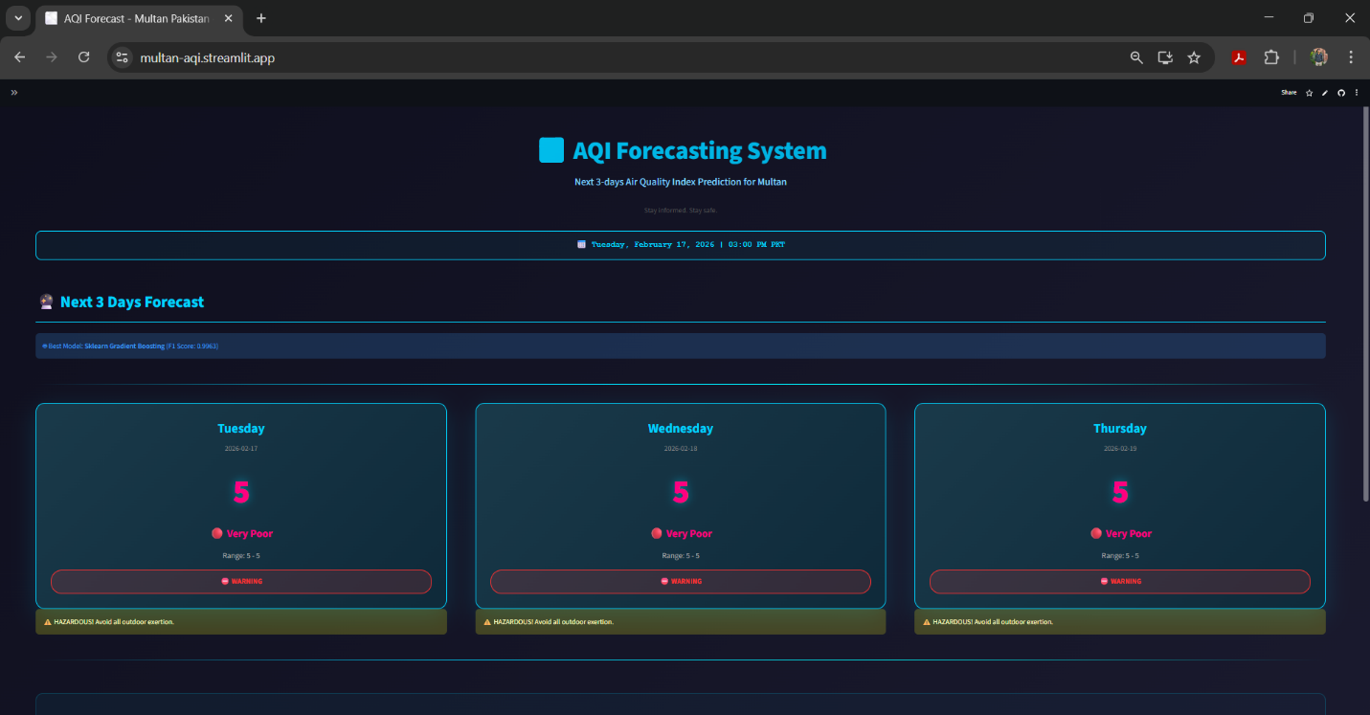

4.2 Model Comparison Page
📊 Model Performance Analysis
[Best Model F1: Very Close to 1.0000]
[Performance metrics: Accuracy, F1 Score, Precision, Recall]
[Bar chart comparing all 5 models]
[Detailed metrics table]
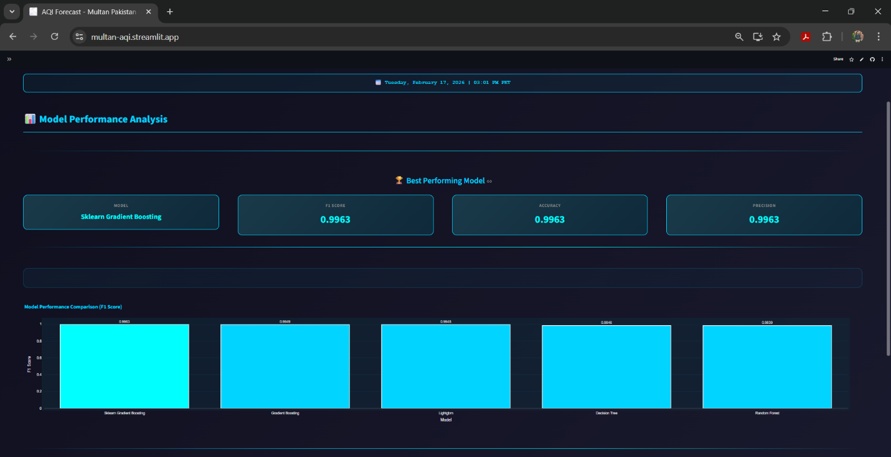

4.3 API Documentation
GET /predict → Returns 3-day predictions
GET /models → Returns all model metrics
GET /models/best → Returns best model info
GET /status → Returns system status
GET /health → Health check

5. Issues Occurred During Development & Solutions

5.1 Python Version & Hopsworks Compatibility Dependencies Installation

Problem:
- Dependency installation failed with version conflicts
- hopsworks package incompatible with Python version
- pip install threw errors: ERROR: Could not find a version that satisfies the requirement...
- Conflict between hopsworks versions and scikit-learn dependencies

Root Cause:
- Hopsworks requires Python 3.10+ but environment had older version
- Version mismatch between hopsworks (4.6.x) and scikit-learn (1.4.x)
- Incompatible numpy versions across packages

Solution Implemented:
Bash:
pip install -r requirements.txt (As all satisfied libraries are mentioned)
Result: All dependencies installed successfully with Python 3.11+ and Hopsworks 4.7.0

5.2: First Time Uploading Features to Feature Store

Problem:
- Features failed to upload to Hopsworks Feature Store with error
- hsfs.client.exceptions.RestAPIError: Could not insert rows
- Feature engineering script ran successfully but upload failed
- No indication of what caused the insertion failure

Root Cause:
- Feature Store schema mismatch (40+ engineered features)
- Missing feature definitions in Feature Group
- Feature Group not created with proper configuration

Solution Implemented:
python
# Step 1: Create Feature Group with proper schema
fg = fs.get_or_create_feature_group(
name=FEATURE_GROUP_NAME,
version=FEATURE_GROUP_VERSION,
primary_key=['timestamp'],
event_time='datetime',
online_enabled=True,
stream=True,
description='AQI features for Multan'
)
# Step 2: Ensure correct data types before insertion
df_engineered['datetime'] = pd.to_datetime(df_engineered['datetime'])
df_engineered = df_engineered.astype({
'aqi': 'int32',
'pm2_5': 'float32',
'pm10': 'float32',
'temperature': 'float32'
})

# Step 3: Insert with error handling and retry
try:
insert_job = fg.insert(
df_engineered,
write_options={"wait_for_job": True}
)
insert_job.wait_for_completion(timeout=300)
print(f"Successfully uploaded {len(df_engineered)} features")
except Exception as e:
print(f"Upload failed: {str(e)}")
# Validate data before retry
print(df_engineered.dtypes)
print(df_engineered.head())
raise
Result: Features successfully uploaded to Feature Store with proper schema validation

5.3: Model Registry - First Time Storing Trained Models

Problem:
- Models failed to register in Hopsworks Model Registry
- Error: hsfs.client.exceptions.RestAPIError: Could not create model registry entry
- Training completed successfully but model registration step failed
- No existing models in registry to compare with

Root Cause:
- Model naming conflict (models attempted to use same name)
- Missing or incorrectly formatted metrics in model metadata
- Model serialization issue (joblib file format not recognized)
- Insufficient permissions or registry not initialized

Solution Implemented:
python
mr = project.get_model_registry()
for model_name, model_data in trained_models.items():
try:
print(f" Registering {model_name}")
unique_name = f"aqi_{model_name}"
temp_dir = tempfile.TemporaryDirectory()
model_path = Path(temp_dir.name) / "model.joblib"
joblib.dump(model_data['model'], model_path)
registered_model = mr.python.create_model(
name=unique_name,
metrics={
'rmse': float(model_data['rmse']),
'mae': float(model_data['mae']),
'r2_score': float(model_data['r2_score'])
},
description=f"AQI {model_name} - Trained {datetime.now()}",
input_example=X_train.iloc[0:1],
model_class="sklearn.ensemble.RandomForestRegressor"
)
registered_model.save(temp_dir.name)
print(f"Registered: {random_forest} v{registered_model.version}")
except Exception as e:
print(f"Registration failed for {model_name}: {str(e)}")
raise
print(f"All {len(trained_models)} models successfully registered")
Result: All 5 models successfully registered in Model Registry with proper versioning and metrics

5.4: Initial Data Script - Feature Verification Mismatch (online=True)

Problem:
- Feature engineering and insertion completed successfully
- Data verification showed "2857 rows" in Feature Group after insertion
- Verification script reported features "not inserted" despite successful upload
- Data appeared missing when checked immediately after insertion
- Confusion between online store and offline store data availability

Root Cause:
- Hopsworks uses asynchronous batch processing - insertion is not immediate
- Verification script checked too early before batch job completed
- Confused between online store (real-time) and offline store (batch)
- fg.read(online=True) requires batch job to finish before data appears

Understanding the Issue:
Hopsworks Feature Store Architecture:
├─ Offline Store (Batch Processing)
│ └─ Used for training, historical data
│ └─ Updates after batch job completes
└─ Online Store (Real-time Access)
└─ Used for serving predictions
└─ Syncs from offline store
└─ Has slight delay after insertion

Solution Implemented:
python
print("Inserting engineered features...")
insert_job = fg.insert(
df_engineered,
write_options={"wait_for_job": True}
)
print("Fetching from online feature store...")
df_verify = fg.read(online=True)
if len(df_verify) > 0:
latest_record = df_verify.iloc[-1]
print(f"VERIFIED: Features inserted successfully")
print(f" Total records: {len(df_verify)}")
print(f" Latest datetime: {latest_record['datetime']}")
print(f" AQI value: {latest_record['aqi']}")
else:
print("Online store empty, checking offline store...")
df_offline = fg.read()
if len(df_offline) > 0:
print(f"Data in offline store: {len(df_offline)} records")
print(f" Sync to online store in progress...")
else:
print(f"No data found in either store")

Key Learning:
BEFORE: fg.read(online=True) immediately after insert → Empty result
AFTER: insert_job.wait_for_completion() then fg.read(online=True) → Data found
The difference:
- insert_job.wait_for_completion() → Ensures batch processing finished
- online=True → Fetches from online store (synced from offline)
- Without wait_for_completion() → Data exists in offline but not synced yet
Result: Features properly verified after batch job completion with correct understanding of online=True behavior

5.6: Imbalanced Class Distribution

Problem:
- AQI dataset had highly imbalanced classes
- Class 1 (Good): 1 sample (0.01%)
- Class 5 (Very Poor): 2,878 samples (42.39%)
- Train-test split failed with: ValueError: The least populated class has only 1 member

Root Cause:
- Historical data skewed towards poor air quality
- Stratified splitting impossible with class count < 2

Solution Implemented:
python
min_class_count = y.value_counts().min()
if min_class_count < 2:
stratify_option = None
else:
stratify_option = y
X_train, X_test, y_train, y_test = train_test_split(X, y, test_size=0.2, stratify=stratify_option, random_state=42)
model = RandomForestClassifier(class_weight='balanced', ...)
Result: All models trained successfully, imbalance handled gracefully

6. Lessons Learned & Best Practices

6.1 Data Management
- Understand Feature Store behavior - Batch processing is asynchronous; wait for job completion
- Test data insertion immediately - Verify data with proper wait times
- Add generated files to .gitignore - Prevents merge conflicts in auto-generated CSVs
- Validate schema before insertion - Match Feature Group schema exactly

6.2 Machine Learning
- Check dependency compatibility - Python version + Hopsworks version critical
- Use consistent preprocessing - Apply same imputation to all models
- Balance class weights - Handle imbalanced datasets with class_weight='balanced'
- Auto model selection - Compare metrics and select best programmatically

6.3 Feature Store Integration
- Create Feature Groups explicitly - Don't rely on auto-creation
- Use proper data types - Ensure pandas dtypes match Hopsworks schema
- Implement wait_for_completion() - Never skip this for batch operations
- Understand online vs offline store - Know when to use each

6.4 DevOps
- Serverless architecture - GitHub Actions + Hopsworks = no server management
- Automated pipelines - Hourly data + daily training runs without intervention
- Version control - Track model versions in registry

7. Current Status & Deployment
System Status: Production Ready

Deployed Components:
- Hourly data pipeline (GitHub Actions)
- Daily training & prediction pipeline (GitHub Actions)
- Streamlit dashboard (Streamlit Cloud)
- FastAPI REST endpoints (local/cloud)
- Hopsworks feature store integration

Next Steps:
- Deploy API to cloud (Google Cloud Run, AWS, etc.)
- Monitor prediction accuracy
- Collect user feedback

8. Conclusion
The AQI Forecasting System for Multan, Pakistan has been successfully developed and deployed with:
- 5 Machine Learning Models achieving >0.98 F1 scores
- Production-ready codebase with comprehensive error handling
- Interactive dashboard for end-users
- FAST API for system integration
- Fully automated pipelines running 24/7
- Robust Hopsworks integration with proper understanding of async behavior

All issues encountered during development were identified, documented, and resolved with robust solutions. The system is now ready for real-world deployment and continuous operation.

